**Christchurch Case Study**

*While New Zealand may be considered a small country, its smart cities ambitions are anything but small. For two consecutive years New Zealand swept up more recognitions for their smart cities initiatives than any others in the annual Smart City Asia Pacific Awards (SCAPA), a competitive benchmarking program conducted by Council Associate Partner IDC.*

Following the significant earthquakes of 2010/11, Christchurch City Council (CCC) put aside funds for ‘Sensing Cities’ initiatives. In November 2015, the Smart Cities programme was initiated to carry out rapid proof of concept projects.

More than 50 per cent of the world’s population lives in cities and the figure is set to rise to 75 per cent by 2050. While the world’s cities only cover two per cent of the global land area, they account for a staggering 70 per cent of greenhouse gas emissions and share responsibility for global climate change.

As a consequence, we urgently need sustainable solutions to combat these city-focused issues. Smart garbage collection, energy-saving and efficient street and traffic lighting, water and wastewater management, and the reduction of CO2 emissions from motor vehicles are all essential elements of the whole solution.

Christchurch is using smart sensors to ensure rubbish bins are emptied at the right time.

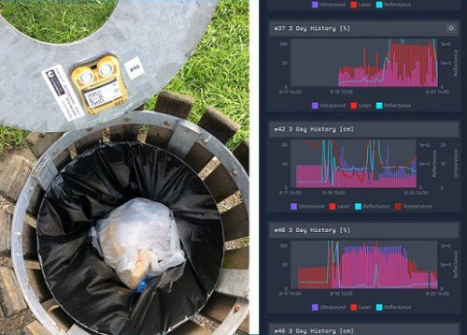

Overflowing public rubbish bins are a frequent source of complaints from residents. City’s rubbish collection contractors work constantly to empty the city’s bins but they don’t know until they arrive at the site whether they’ll find an empty bin, a full one or an overflowing mess.

The bin sensor trial uses LevelSense sensors, which were developed by Christchurch company PiP IoT, to check rubbish levels. The sensors allow city council’s contractors to recognise optimal waste collection times and recommend optimal collection routes. As a result, Council operational managers can find out whether council have the right number of bins in the right places to meet public demand.

**Level Sensor Spec**

#### Ultra-rugged tank and bin level measurement with GPS position and movement monitoring.

Monitor fill-level and dynamic status of your remote tank, bin or other container assets in real time for improved service management outcomes.

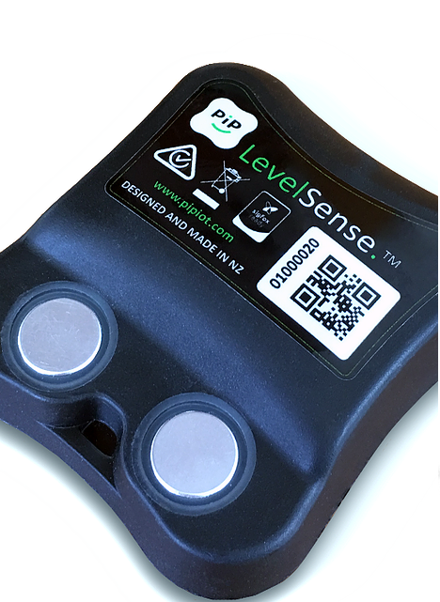

KEY FEATURES

#### TANK AND BIN LEVEL SENSING

#### TILT SENSING CAPABILITY

#### GPS LOCATION / GEO-FENCING CAPABILITY

#### TAMPER / ORIENTATION DETECTION

#### SHOCK / VIBRATION SENSING

#### TEMPERATURE MEASUREMENT

#### EXPECTED BATTERY LIFE  5  YEARS*

#### LOW POWER NETWORK - LPWAN CONNECTIVITY

#### REAL-TIME ANALYTICS

#### MOBILE / WEB REPORTING SIGFOX CERTIFIED CLASS 0

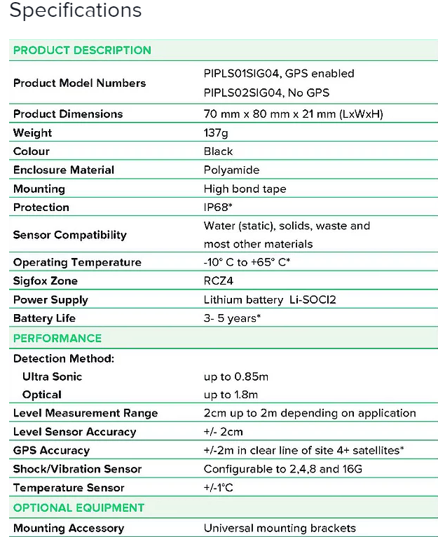

**How the sensors work**

A small unit mounted on the inside of the bin lid uses sonar, which detects the rubbish level and transmits readings to the monitoring system.

A dashboard shows the status of each bin. When rubbish reaches a specified level, the system alerts the contractor that the bin needs emptying.

**Anticipated outcomes**

* Reduction in CO2 emissions and pollution – fewer rubbish collection trucks on the road for less time, which means lower fuel consumption and lower greenhouse gas emissions. Fewer collection trucks on the road will also mean less noise pollution, air pollution, and less wear and tear on our road network.
* Reduction in operational costs – managing waste takes a large portion of our rates dollar. Bin level sensors and monitoring solutions have been known to reduce waste collection costs by up to 50 per cent (fewer collections mean less money spent on driver hours, fuel and truck maintenance).
* Significant reduction in overflowing rubbish bins – overflowing rubbish is a breeding ground for bacteria, insects and pests because of accumulated rubbish. It’s a public nuisance and unpleasant for residents and visitors to our garden city.
* Identifies the use (or misuse) of public rubbish bins – for example, sudden spikes in rubbish levels at night can indicate that household rubbish is being dumped illegally from residents or freedom campers.

CCC selected local company PiP IoT for a pilot to test new sensor technology in the combat against overflowing rubbish bins with the objective of creating operational efficiencies and an enhanced streetscape for citizens.

PiP IoT has rolled out [LevelSense™](https://www.pipiot.com/levelsense) devices to ten bins around rubbish trouble spots, including a city park and retail area. Notifications are being sent to contractors’ phones and bin status across the city can be viewed in an online dashboard telling them how full each bin is. Rubbish levels are also being tracked, providing a graphic illustration of when the bins are used most.

The PiP [LevelSense™](https://www.pipiot.com/levelsense) devices include GPS location along with tilt and shock monitoring capability and temperature sensing in case of a fire. They use a battery that will last for three to five years.

Ed Hadfield, Operations Manager at Recreational Services, the CCC contractor which manages the bins, said "The cool thing about this is that it's allowing us to utilise our resources where they're needed the most”.  
Smart Cities Programme Manager Teresa McCallum says the project shows how technology can be used to solve everyday problems.

“We’re really excited about the potential of these bin sensors to clean up an issue that causes a lot of annoyance and inconvenience to the community."

"It’s another example of the way Smart Cities is working alongside local companies to foster innovation that benefits our city and can be used throughout New Zealand and beyond. Apart from being more efficient, it’s an innovative way to make our city smarter, more sustainable, and get rid of overflowing rubbish complaints for good.”

**Waste Collection using ACO update rules**

In the traveling salesman problem, a set of cities is given and the distance between each of them is known. The goal is to find the shortest tour that allows each city to be visited once and only once. In more mathematical terms, the goal is to find a Hamiltonian tour of minimal length on a fully connected graph. In ant colony optimization, the problem is attacked by simulating a number of artificial ants moving on a graph that encodes the problem itself: each vertex represents a city and each edge represents a connection between two cities. A variable called pheromone is associated with each edge and can be read and modified by ants. Ant colony optimization is an iterative algorithm. At each iteration, a number of artificial ants are considered. Each of them builds a solution by walking from vertex to vertex on the graph with the constraint of not visiting any vertex that it has already visited in its walk. At each step of the solution construction, an ant selects the following vertex to be visited according to a stochastic mechanism that is biased by the pheromone: when in vertex i, the following vertex is selected stochastically among the previously unvisited ones. In particular, if j has not been previously visited, it can be selected with a probability that is proportional to the pheromone associated with edge (i, j). At the end of an iteration, on the basis of the quality of the solutions constructed by the ants, the pheromone values are modified in order to bias ants in future iterations to construct solutions similar to the best ones previously constructed.

Each ant builds a solution by using two types of information locally accessible: (1) problem-specific information, i.e., distance among cities, and (2) information added by ants, as pheromone values, during previous iterations of the algorithm. While building a solution, each ant collects information on the problem characteristics and on its own performance, and uses this information to modify the representation of the problem. The modified representation is the new environment shared by all the ants and seen locally by other ants. The representation of the problem is modified in such a way that information contained in past good solutions can be exploited to build new better solutions. As mentioned earlier, this form of indirect communication mediated by the environment is called stigmergy, and is typical of social insects (Dorigo, Maniezzo and Colorni, 1996, Dorigo and Gambardella, 1997).

Suppose an ant k (in m ants) is at city i, and Nk is the set of k’s unvisited cities. Then, the ant chooses city j to visit next in a probabilistic way as follows:

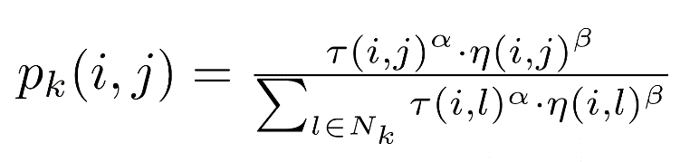

(1)

Here, η(i,j) represents the problem-specific information, and in TSP, it is the reciprocal of the distance between two cities i and j. τ(i,j) represents the information about the ant trails, i.e., the pheromone value on the route between two cities i and j. α and β are non-negative constants, and their values determine whether η (local information) or τ (global information) has more weight in the formula. τ(i,j) is updated accordingly to the following rules, when one iteration is done.



(2)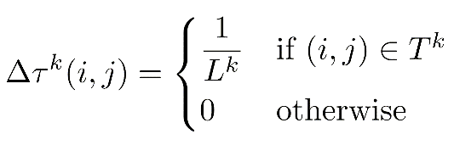

(3)

Here, Tkrepresents the set of all routes from the start city to the goal city, and Lkrepresents the collective distance from the start city to the goal city. In ant-colony algorithms, the pheromone value added to a specific route is determined by the reciprocal of the total distance and the pheromone also disappears over time, where ρ represents the evaporation rate, such that newly added pheromone has more influence than old pheromone additions. Thus, after many of iterations, one can expect to obtain an approximately optimal route selection.

As demonstrated here, ACO algorithms have been applied to dynamic versions of the TSP, where either the distance between some pairs of cities changes, or cities are dynamically added or removed from the set of cities to be visited. Additionally, an ACO algorithm has also been applied to dynamic vehicle routing problems, showing good behaviour on randomly generated problem instances and on real-world instances as well (Dorigo and Gambardella, 1997). This makes it the perfect algorithm for our dynamic waste collection vehicle routing scenario.

Our waste collection problem for Christchurch poses a dynamic instance of the TSP, where cities are represented by containers and containers which are (almost) empty are not collected. Containers which are full or almost full will appear in the bin collection route dashboard and will be collected.